2014年3月
March, 2014

公益金百萬行
公益金百万行
The Community Chest Walk

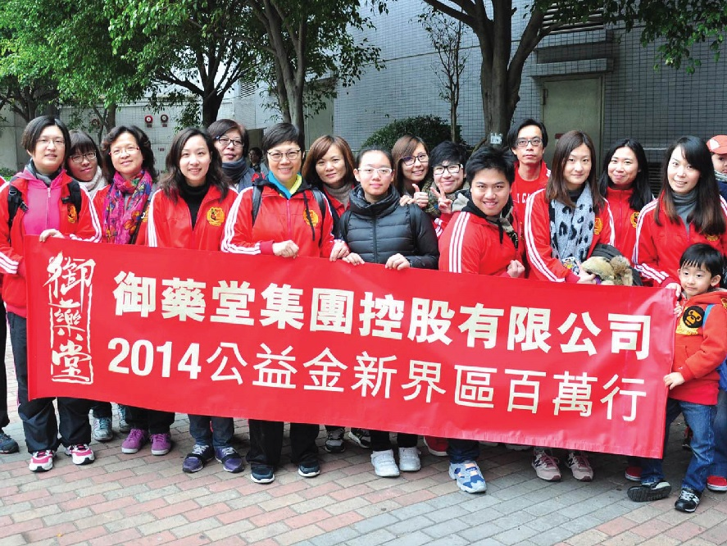

「御藥堂」參加由香港公益金所舉辦的《新界區百萬行 - 昂船洲大橋》，由昂船洲高架路出發，沿途經過昂船洲大橋和青衣東高架路，至南灣隧道西面出口為終點，總路程約四公里。是次活動是為本港「兒童及青年服務」籌款，而「御藥堂」一向熱心公益，由多個來自不同部門的同事組隊參加，為本港公益出一分力。

「御药堂」参加由香港公益金所举办的《新界区百万行- 昂船洲大桥》，由昂船洲高架路出发，沿途经过昂船洲大桥和青衣东高架路，至南湾隧道西面出口为终点，总路程约四公里。是次活动是为本港「儿童及青年服务」筹款，而「御药堂」一向热心公益，由多个来自不同部门的同事组队参加，为本港公益出一分力。

Royal Medic participated “New Territories Walk – Stonecutters Bridge”, which is held by The Community Chest Walk. The walk started from Ngong Shuen Chau Viaduct, via Stonecutters Bridge, East Tsing Yi Viaduct and ends at West Portal of Nam Wan Tunnel. The whole distance of walk was approximately 4 KM. This walk was a fund-raising event for the service of children and teenagers. Royal Medic always devotes to charity activities, and made a team consisting of various staffs from different departments to participate in order to make a contribution in society.

